Image

Distributed Systems

Live Video Streaming Service with Facial Recognition

Dominik Wawak

20089042

Table of Contents

1

Introduction 3

Architecture - Diagram 3

Architecture 4

Technologies 4

Functional and nonfunctional requirements 5

Implementation 6

Design 6

Implementation 6

First attempt 7

Integration with web application 9

Code walkthrough 9

The server 14

Conclusion 15

Modification 15

Future Improvements 15

References 16

Appendix 17

Introduction

This projects main aim is to create a web service that will use a web cam to detect and recognize human faces. Facial recognition is used in many applications in the world today. The most obvious is security as mobile phone users use facial recognition to unlock their phones. Other applications can be seen in the automotive industry and the entertainment video conferencing industry.

To start with facial recognition, we first need to find a face in the image and crop the image, so it just focuses on the facial features. Next the libraries that will be discussed later are used to pick out and map the features of the face to be sent to the trained neural network.

The definition of a neural network by IBM is "Neural networks reflect the behavior of the human brain, allowing computer programs to recognize patterns and solve common problems in the fields of AI, machine learning, and deep learning.” [3]. For our problem of facial recognition, we have a pre trained neural network that takes the image and generates a feature vector of 128 values. Those values represent the features on the face, we don’t worry about the values as they are computer generated by the model. For the model that was trained we can assume it used a lot of facial data of other people to carefully pick out features in any other test face like we are giving it now.

After the face is detected, a rectangle will be drawn around it and the person’s name will display as well with some other text to verify the match to the user. The application video stream will be accessible to others on the network. For this project the local network is used but this could be easily scaled up with a hosting service Imagesuch as amazon web services or google cloud platform.

Architecture - Diagram

Camera

Clients

Image

Server

Image

ImageImageImage

Facial recognition function

Architecture

The architecture of the application is essentially explained in the diagram above the camera gives the server (in this case the laptop) its video feed based on the image from the feed the laptop looks at its trained faces from the neural network and gives a match if the face is like the one trained. The video feed is available for many clients to access on the network as said before the network used for the project is the local network of the machine.

Image

Technologies

The hardware technologies used for this project are just a laptop specifically a MacBook pro-2021.

The programming language used mainly for this project version 3.9.13 isImage python with a bit of html to view the website.

The project uses flask which is a python framework used from creating web applications.

Socket IO is another python library that allows bidirectional and real time eventImage based communication between the browser and the server.[5]

EventLet is a library that allows writing asynchronous, coroutine-based code that looks like standard synchronous Python.[4] This means that we can have multiple clients connecting to our application at any one time.

Image

Open CV is a popular computer vision library that allows for real time vision processing and for this application facial recognition. This takes the feed from the in-built webcam from the laptop.

The face_recognition library does the magic of finding where the face is in the image, calculating the 128 number vector and calculating the distances between the trained model and the test image.

Dlib is used in many machine learning algorithms, in these projects it is used to find faces. It enables facial recognition library to work and cmake is used to generate build files for another system like Dlib that uses a C compiler.

Functional and nonfunctional requirements

Functional Requirements:

* Transform Original Video
* Heterogeneous Delivery
* The application must be able to detect at least 3 faces.
* The application must be able to be a webserver accessible do devices over the network.
* There is now authorisation requirements to access the stream.
* The facial recognition must show the person’s name and the percentage match to the trained face.

Non Functional Requirements:

* The live video should be greater than 15 FPS.
* The quality of the video should be on par with already available streaming qualities at least greater than 480p.
* The faces should be of people in the class for demo purposes.
* The server is hosted on local host machine.
* The project is created with python and the web service provided by python flask library.

Implementation

# Design

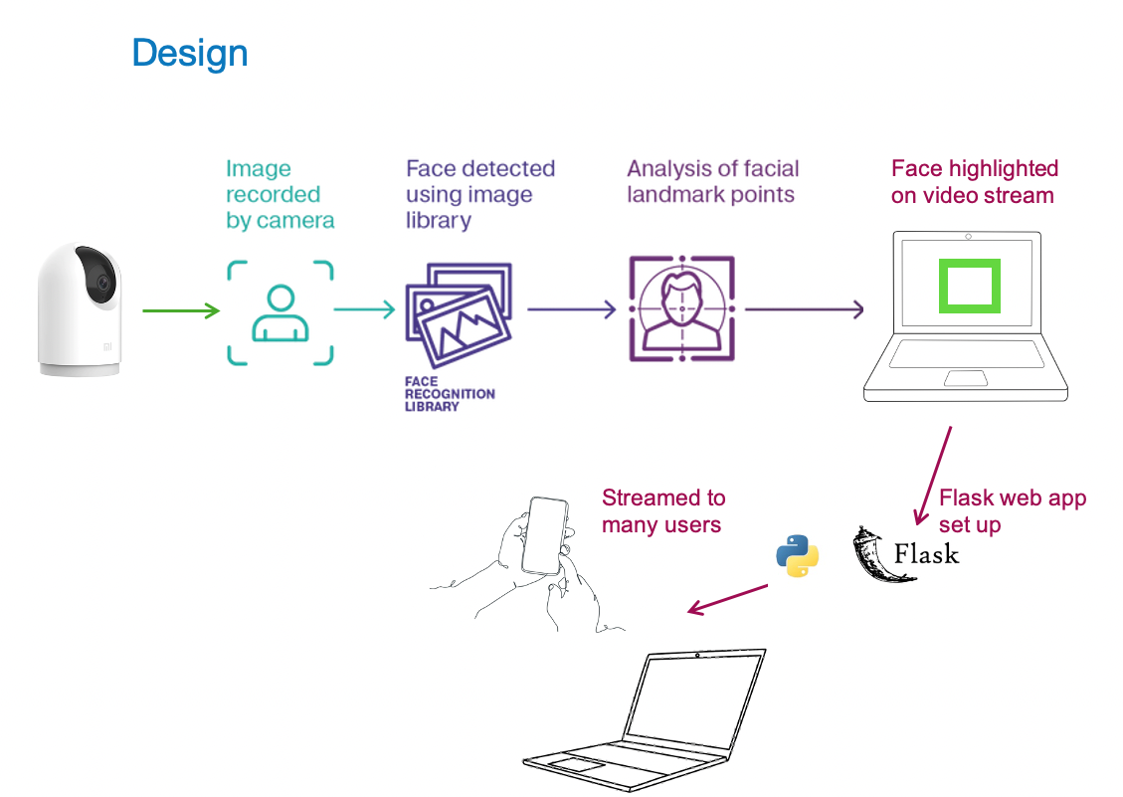

The above diagram is an illustration of how this application works. The webcam or some external camera feed is used to stream the image to the python script that uses a facial recognition library and compares the face seen by the camera to the one it has encodings for. If a face is found it is highlighted on the live stream. The live stream is made possible using the flask python library that allows for the creation of web apps with a python script. The streaming and multithreading to multiple clients is done with waitress.

# Implementation

This project started off with taking this past project [appendix 2] and getting it up and running by installing the dependencies that were listed above. That project used HaarCascades an algorithm that is used for facial detection and is a different method to the Dlib used in my project. Main difference is that HaarCascades returns a multi-dimensional numpy array that represents the faces in the image while dlib returns rectangular objects [2]. This research paper however shows that HaarCascades method is 60% accurate while the dlib method is 85% accurate. [7]

## First attempt

The biggest challenge of setting up was installing the right versions of the libraries such as SocketIo and eventLet. In my case to solve these problems it was a matter of updating old libraries I already had installed. An example of this was I already had flask installed but it was an old version which I had to uninstall and re install.

When the sample project was working some research was done on facial recognition projects with python. I found many people used dlib and the facial recognition library. Some sample project videos on YouTube that walked through the code proved helpful to achieve the end goal. [1]

The first Iteration of the project was a simple application that used a trained image and a test image with no video feed. The code looked like this: 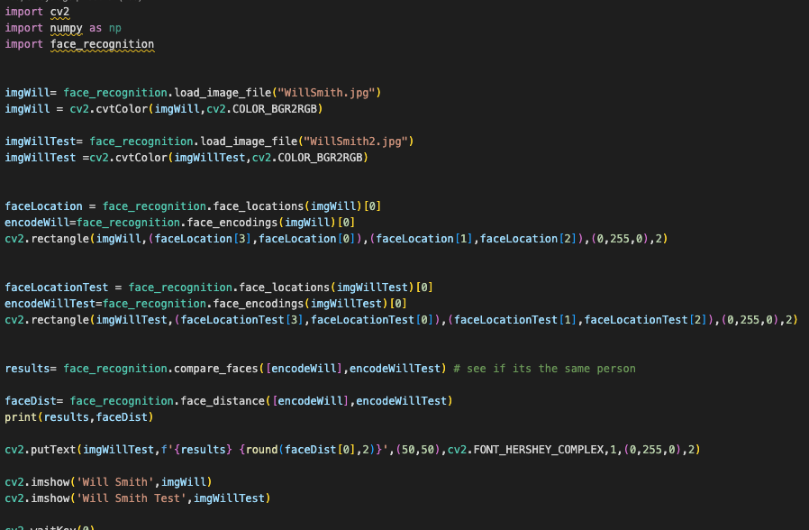

Figure 1 First test code

The above code works the following way:

The images are loaded from a file and converted to RGB (red, green blue) because open cv reads images in a different order (BGR).

Next the face location and encodings are taken from the face recognition library.

A rectangle is drawn around the face location, color green.

Results is a true of false value indicating if the face tested is the same as the one trained.

The face distance is the numerical nonlinear value of how close the recognized face is, usually the lower the better, the optimal value is 0.4.

Next a text box is added just to show the result true or false.

The below image shows the result of the first test. We can see that the image of Will Smith is different on both. The one on the left is the training image and the on the right is the test image with the text and the face distance value.

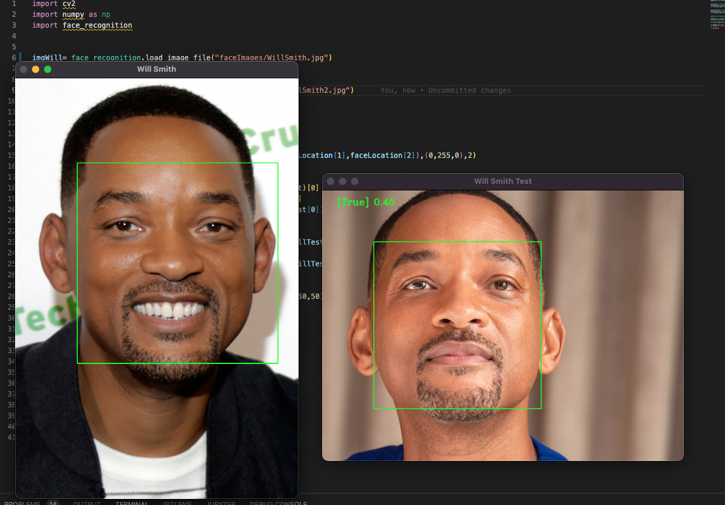

Figure 2 first test result

## Integration with web application

Once the facial recognition was working locally on the laptop and the example web streaming server was also set up it was time to blend the two together to create a facial recognition streaming server.

## Code walkthrough

Below are the requirements that are needed to run the application. They can be found in my repository under the requirements section. (see Appendix A).

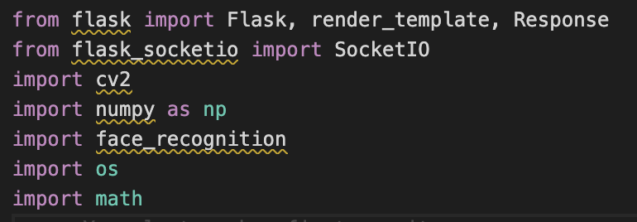

Figure 3 imports

Next small section of the code initializes the flask app and socketio app. Flask allows for web application development with python and socket io allows flask to establish bidirectional communication between clients and server.

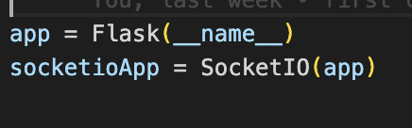

Figure 4 flask and socketio

The following piece of code looks in the project directory and looks at mylist array. That array is a list of files located in a folder called faceImages. The path is read and is turned into an image object with open cv (cv2). The image then gets added to the images array and the name of the image which should be the name of the person should be added to the classNames Array.

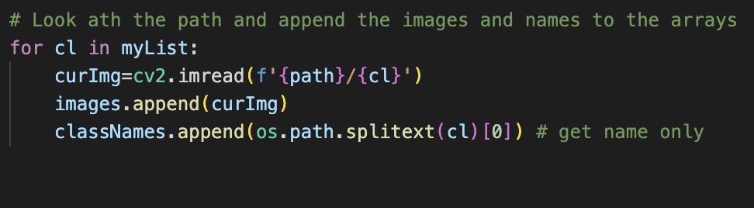

The face distance to confidence function is a helper function we will need later. As mentioned before the face distance is the measurement of how close the face being tested is to the face that was trained, and the encodings were found for. In this case the image being tested is whatever face the webcam or streaming camera can pick up.

The face distance value for when the face gets recognized is around 0.4. However, the face distance value is nonlinear meaning we can’t scale it to be a accuracy measurement of how close we are at recognizing someone’s face. Adam Geitgay a github user has come up with this function to calculate the percentage accuracy of recognizing a face with python’s face_recognition library.

He found that by setting a threshold is 0.6 makes the face comparison stricter and its not wasting time performing comparisons on faces that are completely unrelated. He says that this is not the perfect answer as to get the perfect result you would need to build your own test set and evaluate the intervals.

His solution when setting the threshold to something like this looked like this on the graph: 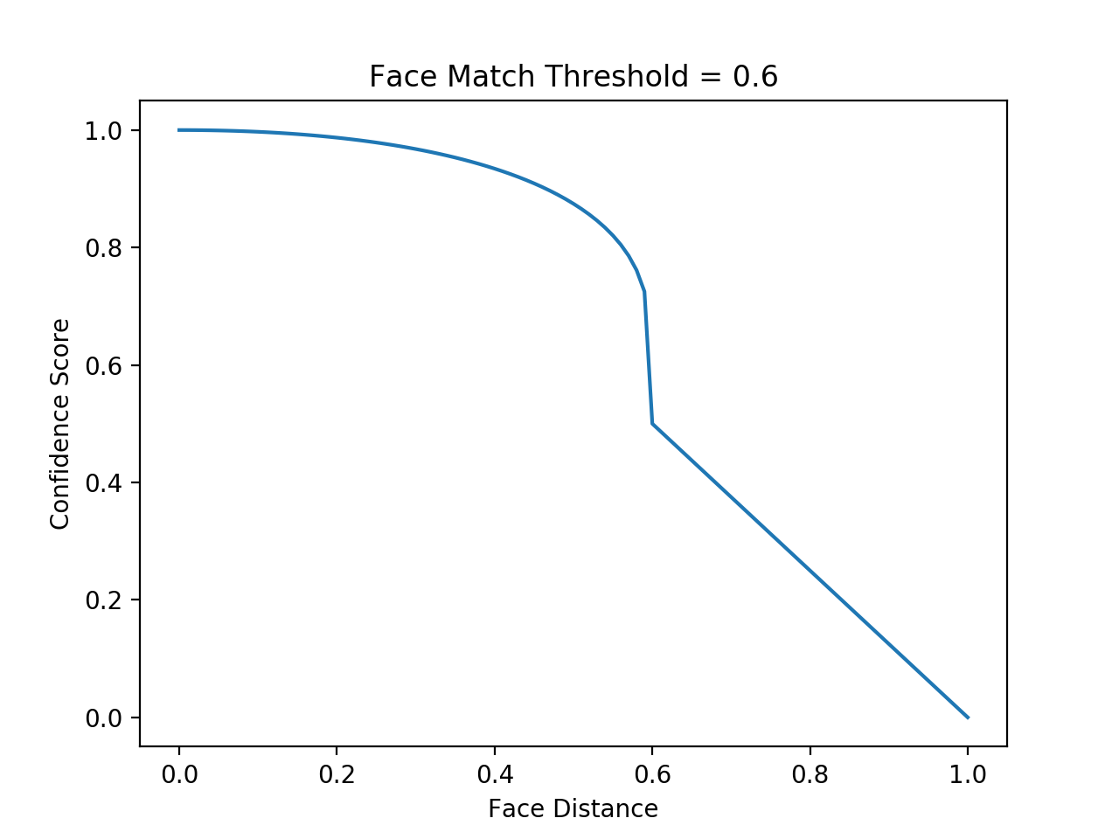

His function transforms the nonlinear curve into something linear that could be mapped to a percentage value.

This is the function code below. This function will be used later to display on the live stream the percentage of accuracy in the face recognition.

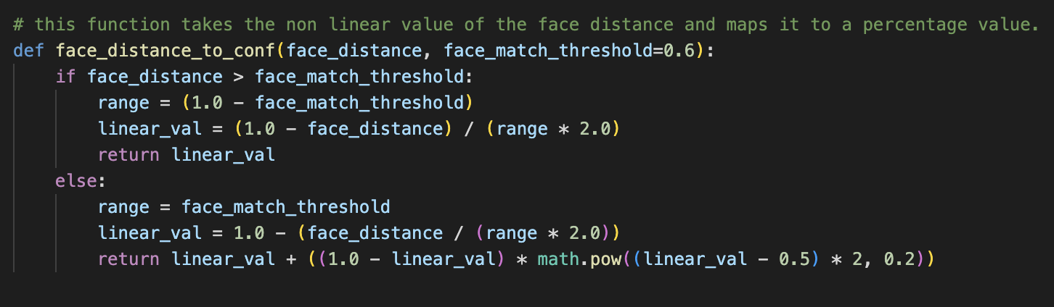

Figure 5 Calculating Accuracy as a percentage

The next function that is needed is the find encodings function. Encodings are the 128 vector values that represent features of a face. The face_recognition library is provided by researchers and has been trained on over 3 million faces [8]. Because it is trained on so many faces it is easier for it to see the minute differences ie unique features in people’s faces.

The function loops through the array of images converts them to RBG and finds the encodings, then the encodings get added to an array and that array is returned and will be used later to compare with the image frame from the camera.

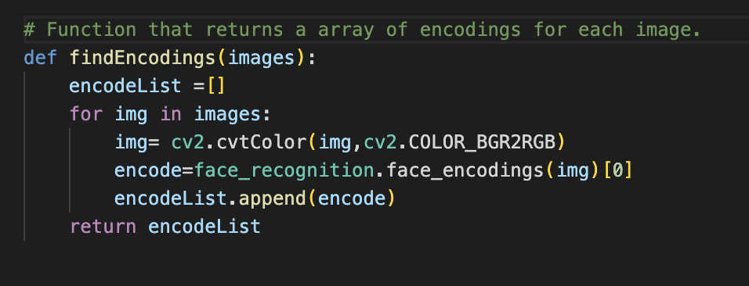

Figure 6 encodings function

Figure 7 below shows this function being called and giving feedback to the terminal that the encodings are complete, because this method takes a while. The cap variable is the video stream from the camera.

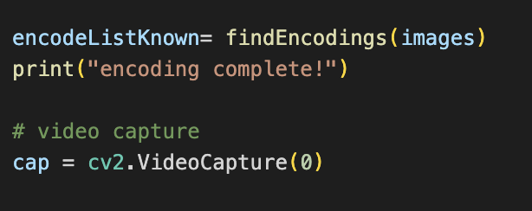

Figure 7 video capture

Now the main function of the project, gen_frames() starts with an infinite loop that first reads the image from the frame and tries to resize it to make the computation time faster.

The compressed image is then converted to RGB because as explained before open cv works with BGR which is the colors arranged in a opposite way. Then we look for faces in the frame, there could be multiple so we want to get all of them, and we want to take the encodings for these faces to so they can be compared to the encodings computed from the local images for comparison.

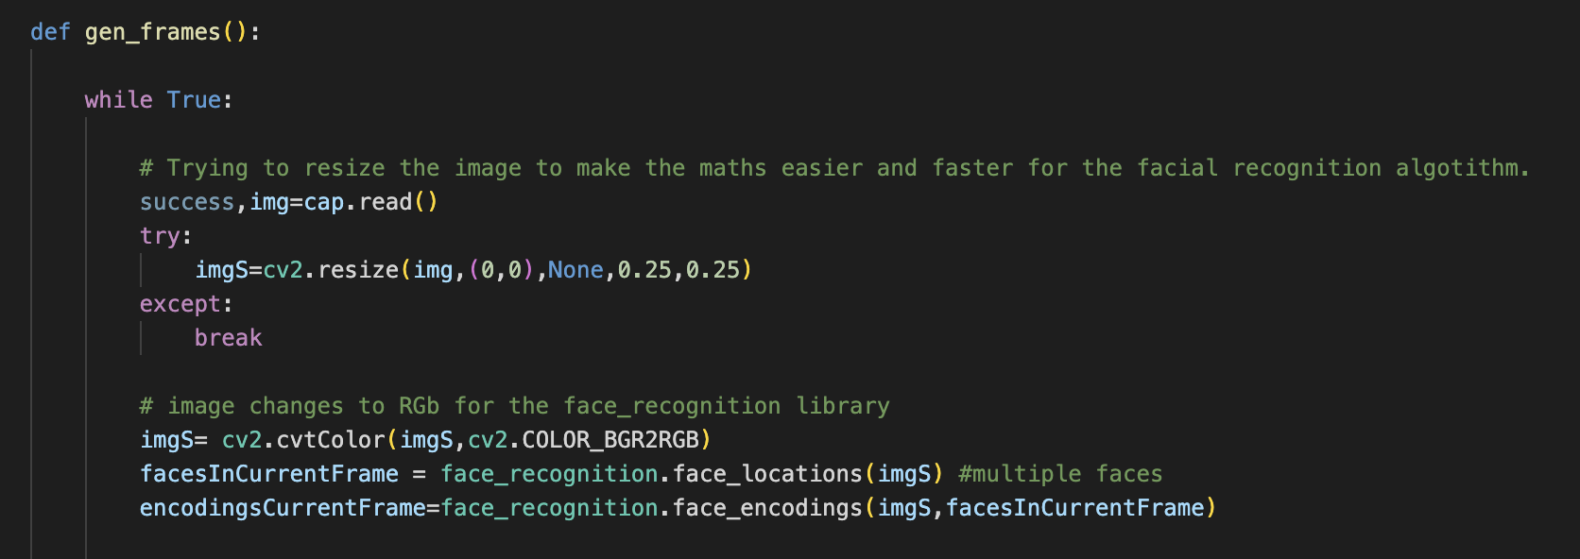

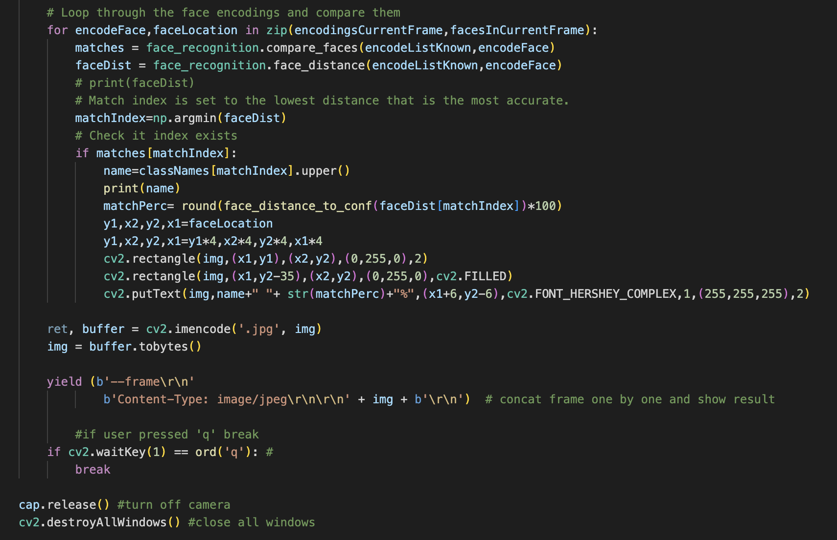

Figure 8 gen_frames()

The next part of the function illustrated in figure 8 is the for loop that needs to loop through every face found in the frame and check is there is any match between them, if there is a match then the name is printed to the console, and we use the function from above to get the accuracy percentage. We can get the coordinates from the face location and that way the rectangle can be drawn around the face and the text is placed with the name and the percentage match. After that loop the image is made into a jpg so it could be served to a browser. A small piece of code allows to quit the application when the q key is pressed, once it is the camera turns off and application stops.

After that function the flask functions help to stream the images onto a homepage. The run function will run the app.

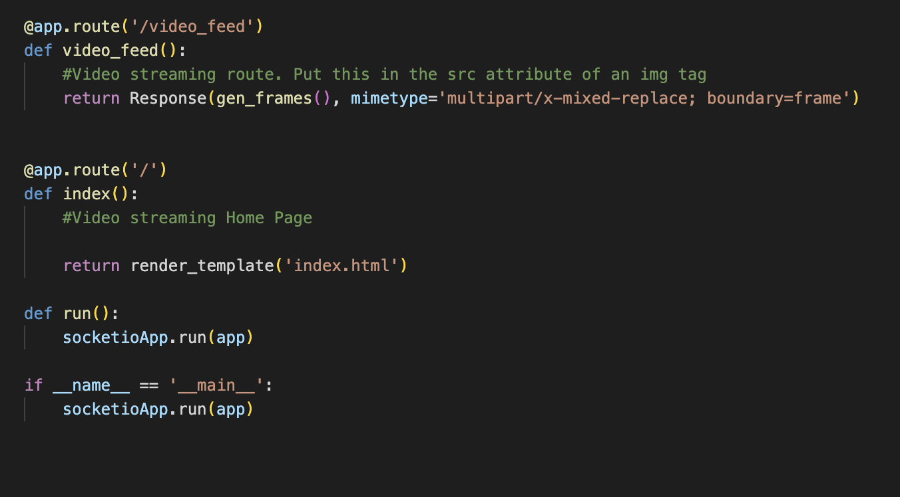

Figure 9 application

## The server

The server is the program that’s run by calling the command python3 server.py.

It imports the application from the livevideo file explained above and by the help of eventlet starts the server and it is accessible to clients on the same network since we are using local host. (Figure 10)

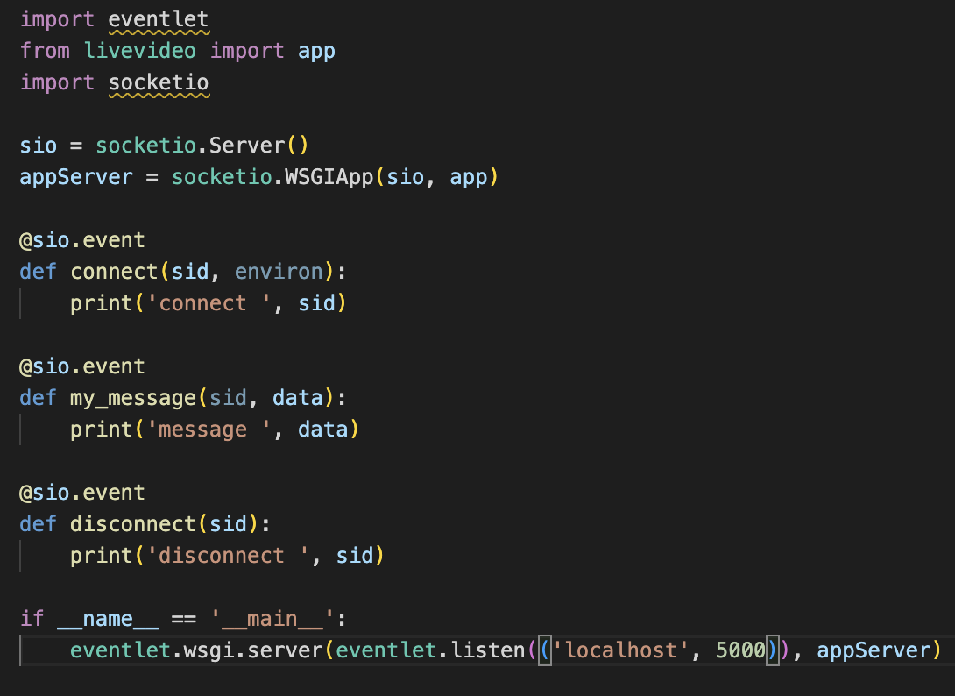

Figure 10 server.py

# Conclusion

This project turned out very interesting and showed a lot about how hard the mainstream media companies must work on developing a reliable and decent streaming services.

The project has taught me a lot on the theory behind facial recognition and web services. It was a struggle to get everything set up and to have all the correct versions of libraries and their dependencies.

It also got me thinking about the applications of such services. Many video conferencing cameras already implement facial recognition and following features to follow presenters on stage.

Surveillance cameras in prisons and protected zones could also make attendance checking jobs a lot easier.

I think that facial recognition technology is rapidly evolving and is more widely accessible and easier to implement than before.

## Modification

I have one modification which I included in the project that also involves a bit of error handling. In the gen frames each frame is being read and when we are streaming high quality video the processing time of the facial recognition could take a long time and slow our quality of service down. Therefore, resizing the image makes the following jobs easier and faster to find the encodings. The error checking here is the try and except block because sometimes that img is not read quickly enough by open cv and the webserver would crash trying to resize a null image.

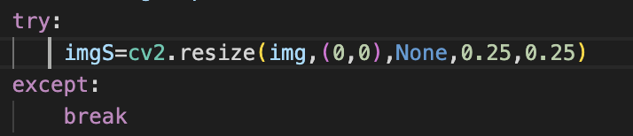

Figure 11 image resize

Another Modification I added is multi-threading with waitress, flask by itself only supports single client per server. A python library called waitress allows multiple clients by threading the application. Here is an example of the code:

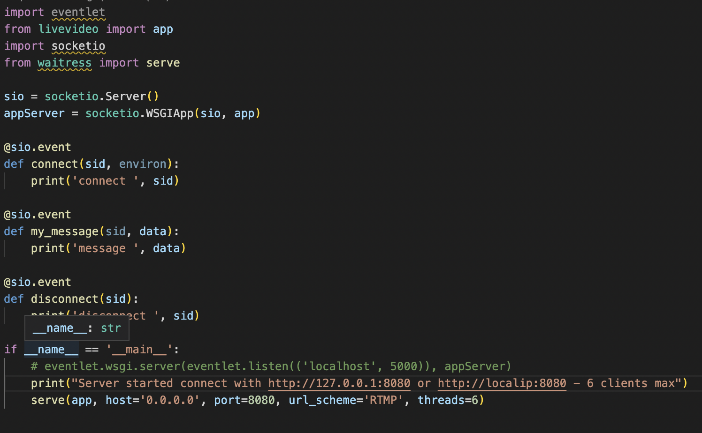

Figure 12 multi-threading

The last line in this code allows for up to 6 concurrent connections to the application.

## Future Improvements

There without a doubt are many more modifications that could be added to this project. One of such is not performing the recognition on every frame and skipping two frames for example. Threads could also be used to display the image and perform the computation on the side.

Getting this application hosted on a cloud service such as Amazon cloud services would make it accessible to any device on any network.

# References

* [1] Murtaza’s Workshop, 2020. FACE RECOGNITION + ATTENDANCE PROJECT. [online] Youtube.com. Available at: <https://www.youtube.com/watch?v=sz25xxF_AVE&t=255s> [Accessed 24 November 2022].
* [2] Adam Geitgey, 2016. Machine Learinig is fun Part 4. [online] medium.com. Available at: <<https://medium.com/@ageitgey/machine-learning-is-fun-part-4-modern-face-recognition-with-deep-learning-c3cffc121d78>>[Accessed 24 November 2022].
* [3] IBM, 2020. Neural Networks. [online] IBM.com. Available at: <

<https://www.ibm.com/cloud/learn/neural-networks>> [Accessed 24 November 2022].

* [4] 2010. Eventlet [online] palletsprojects.com. Available at: < https://flask.palletsprojects.com/en/2.2.x/deploying/eventlet/> [Accessed 24 November 2022].
* [5] 2022. Socket.IO [online] socketio.com. Available at: < <https://socket.io/docs/v2/>>[Accessed 24 November 2022].
* [6] Md Terequl Islam, 2020. Facial landmarks detection with Dlib and haarcascade. [online] medium.com. Available at: < https://medium.com/analytics-vidhya/facial-landmarks-detection-with-dlib-and-haar-cascade-e3c8195131d7>[Accessed 24 November 2022].
* [7] Narazlin Ibrahim, 2019. Haar Cascade Vs Facial Landmarks Technique for Face Recognition Uniqueness. [online] research paper. Available at: < https://www.warse.org/IJATCSE/static/pdf/file/ijatcse77816sl2019.pdf >[Accessed 24 November 2022].
* [8] Martin Anderson, 2021.Face detection and recognition with dlib. [online] width.ai . Available at: < https://www.width.ai/post/facial-detection-and-recognition-with-dlib

>[Accessed 24 November 2022].

# Appendix

[1] my code repository: <https://github.com/DominikWawak/facialRecognitionRemotely>

[2] past project start code: https://github.com/ageitgey/face_recognition/wiki/Calculating-Accuracy-as-a-Percentage

[3] my video demo: